Manila Water Company
technical specification - REPORT
DID_R2R_180
Process Payment Acknowledgement Files

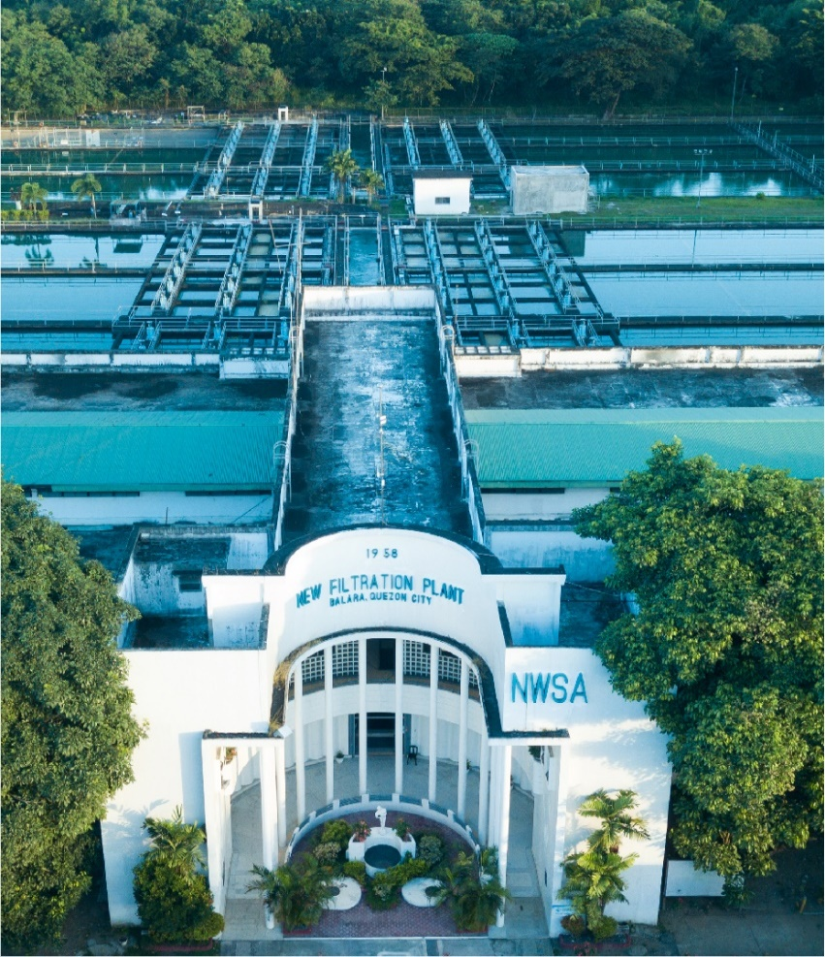



Contents
1 Document Organization 5
1.1 Document Log 5
1.2 Integration, Document Reference 5
2 Program Attributes 6
2.1 Selection Screen 6
2.2 Validation of Selection Criteria 7
2.3 CDS Views/AMDP/Table Function 7
2.3.1 Selection Condition 7
2.3.2 Join Condition 7
2.3.3 Fields 7
2.3.4 Additional Details 7
2.3.5 GIT Repository Details 7
2.4 Authorization Requirements 8
2.4.1 Definition 8
2.4.2 Defined Fields 8
2.4.3 Procedure 8
2.4.4 DCL Details 8
2.4.5 BTP Details 8
2.5 Technical Flow Diagram 8
2.6 UI Details 8
2.6.1 UI Mock Screens 8
2.6.2 Navigations 9
2.6.3 Actions 9
2.6.4 Validations 9
2.6.5 Other Details 10
2.7 Processing Logic 10
2.8 Reusable Code 10
2.9 Messages 10
2.10 Subroutines 11
3 Report Output 11
3.1 Output Method 11
3.2 Main Heading 11
3.3 Sub Heading 11
3.4 Layout / UI Design 11
3.5 Totaling 12
3.6 Sorting 12
3.7 Page Break 12
3.8 Error Handling 12
3.9 Report Header & Footer 12
4 Assumptions in Technical Design 12
5 Open Issues in Technical Design 12
6 Unit Test Results 12
7 Related Documentation 13

Document Organization
This section provides details about this document, previous version(s) of this document and the document(s) referred.

Document Log
Following table mentions the version changes and the processer(s):
Version | Status | Date | Version Created by (Name/E-Mail/Company) | Role | Comments
 | Draft | May 21, 2025 | Vipul Tamboli | Author

Integration, Document Reference

S. No. | Referred Document Name | Referred Document Version | Referred Document URL (Optional)
N/A | N/A | N/A | N/A

Program Attributes
Program title | Process Payment Acknowledgement File
Program Name | ZAB_R2R_180_PROCESS_PAYMENT
Program Type | Executable
Package | ZS4_MWC_R2R_TRM
Authorization Group | N/A

Transaction Code | ZTR_TRM_ACK_PROC
Include Programs | ZIN_R2R_PROCESS_PAYMENT_TOP  ZIN_R2R_PROCESS_PAYMENT_E01  ZIN_R2R_PROCESS_PAYMENT_F01

SAP Tables Read | ACDOCA  PAYR  REGUH  SETLEAF  T012K
Custom Indexes | N/A
CDS Views | N/A
OData Service | N/A
Business Object | N/A
Group Name | N/A
Catalog Name | N/A

Selection Screen
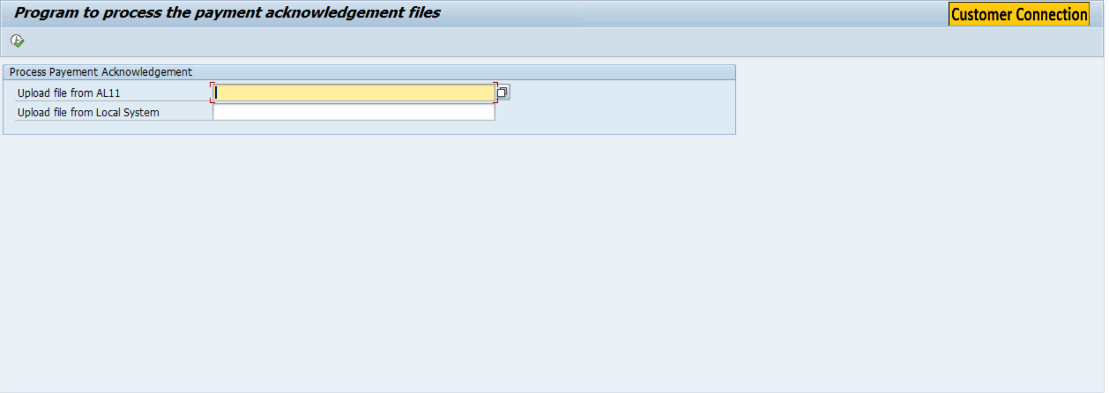

Validation of Selection Criteria
N/A

CDS Views/AMDP/Table Function
N/A

Selection Condition
N/A

Join Condition
N/A

Fields

N/A

Additional Details
N/A

GIT Repository Details

Development Details
GIT Location | N/A
GIT URL | N/A

Authorization Requirements
N/A

Definition
N/A

Defined Fields
N/A

DCL Details
N/A

BTP Details

xs-security Configuration | N/A
IDP Setup | N/A
BTP Role Collections | N/A

Technical Flow Diagram
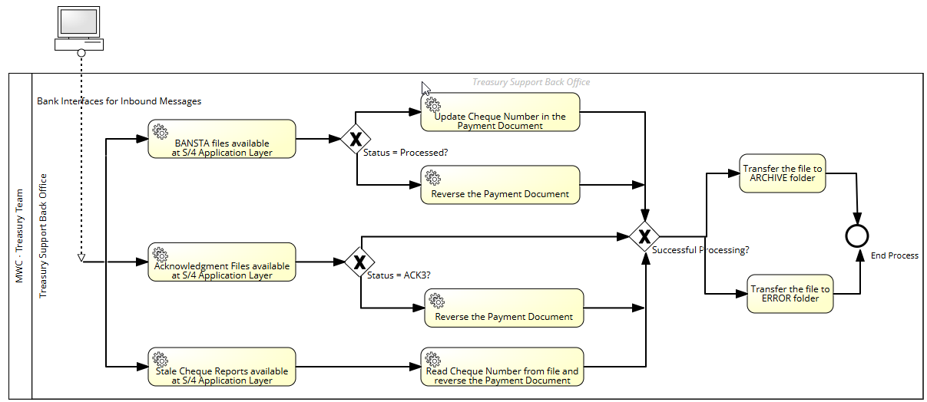

UI Details
N/A

UI Mock Screens

Application Name
Site | N/A
URL | N/A
Mockup | N/A

Navigations

Source View | Target View / URL | Pattern
N/A | N/A | N/A

Actions

Application | Screen(s) | Action | Type | Action Description
N/A | N/A | N/A | N/A | N/A

Validations
Application | Screen(s) | Field/Button | Validation Logic – Method, function details
N/A | N/A | N/A | N/A

Other Details
N/A

Processing Logic
- Two input fields are provided on the selection screen:
  - AL11 Path Field: Allows users to input or browse a file stored in the AL11 application server directory.
  - Local File Upload Field: Allows users to select and upload a file from their local computer using a file browser window.
  - F4 help is implemented for both fields to enable browsing.
  - Only one of the two fields needs to be filled to proceed.

- Based on the populated field, the file is read:
  - If the AL11 path is provided, the file is read from the application server using standard SAP file reading functions.
  - If the local file is uploaded, it is read using GUI frontend services.
  - The file content is read into an internal table for further processing.

- The first line (or header) of the file is analyzed to determine its type.
- The file is classified into one of the following categories:
  - BANSTA
  - ACKNOWLEDGEMENT
  - STALE CHECK
- If the file does not match any known type, an error is raised and processing is stopped.

- BANSTA File Processing
- The file is parsed into a structured internal table for check/payment status data.
- Each record is evaluated for its processing status:
  - If status = ‘PROCESSED’, a BDC is triggered to update the check number in the relevant transaction.
  - If status ≠ ‘PROCESSED’, function module J_1B_FBRA_POSTING_AUFRUFEN is called to reverse the payement document.
- Acknowledgement File Processing
- Each record is validated to ensure key fields are present, such as:
  - Company Code
  - Payment Document Number
  - Fiscal Year
- If the record is valid:
  - A custom SAP program is called using SUBMIT to reverse the payment document.
  - This reversal logic is handled within the external program.

- Error Handling and User Feedback
- If the uploaded file is of an unknown type, an error message is shown.
- Validation failures and reversal errors are captured and shown in the processing log.

Reusable Code
N/A

Messages
N/A

Subroutines
Name | Description
N/A
N/A
N/A

Report Output

Output Method

N/A

Main Heading

Sub Heading
N/A

Layout / UI Design
N/A

Totaling
N/A

Sorting
N/A

Page Break
N/A

Error Handling
N/A

Report Header & Footer
N/A

Assumptions in Technical Design

N/A

Unit Test Results

Scenario # | Input Selection Criteria | Expected Result | Actual Test Pass/Fail
1 | Process BANSTA File of SCB Bank | Payment document is reversed if Status <> Processed.  Cheque Number is updated in the Payment Document if Status = Processed | Pass
2 | Process BANSTA File of RCBC Bank | Payment document is reversed if Status <> Processed.  Cheque Number is updated in the Payment Document if Status = Processed | Pass
3 | Process Acknowledgement Files (Rejection) of SCB Bank | Payment documents are reversed. | Pass
4 | Process Acknowledgement Files (Rejection) of RCBC Bank | Payment documents are reversed. | Pass

Related Documentation

Template Version
Version | Status | Date | Version Created by (Name/E-Mail/Company) | Role | Comments
1.0 | Final | February 11, 2019 | Sweety | Author
1. | Final | March 15, 2022 | Sweety | Author | Updated to accommodate details of Fiori/UI5 Application related artifacts using ABAP programming model for SAP Fiori Elements

